**EXAMPLE #1**

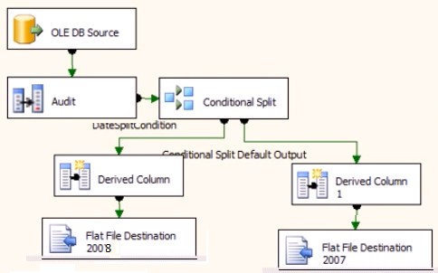

**EXAMPLE #2**

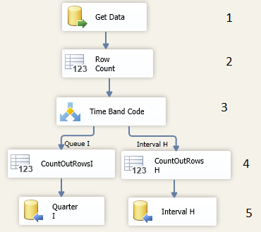

1. **Get Data**

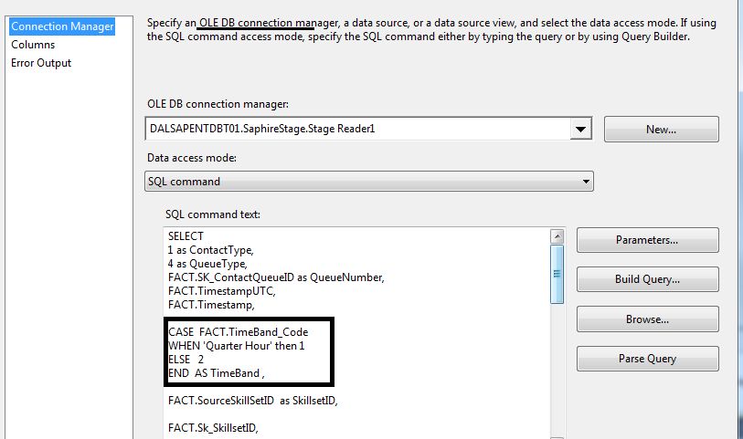

**We use an OLE DB connection** because we must set parameters

WHERE FACT.Sk_JobSystemID =280 AND FACT.SK_DATEID = ?

Click Parameter button to assign parameter

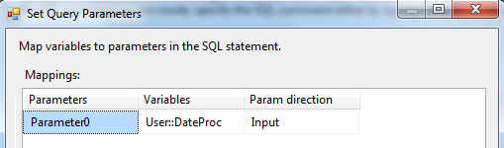

1. Row Count

Set the variable where the Row Count will go

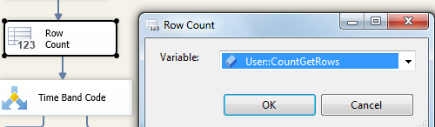

1. Conditional Split

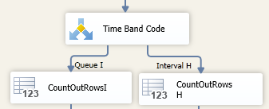

If the TimeBand is 1 insert in one process, if not go to the other process

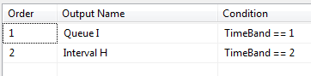

Other option

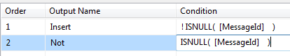

It is assign according to the initial select query

CASE FACT.TimeBand_Code

WHEN 'Quarter Hour' then 1

ELSE 2

END AS TimeBand ,

When setting the flow

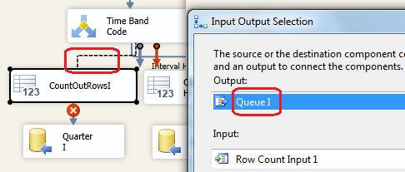

1. Row Count

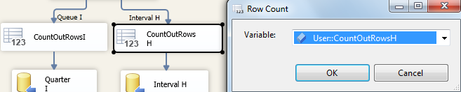

1. Insert

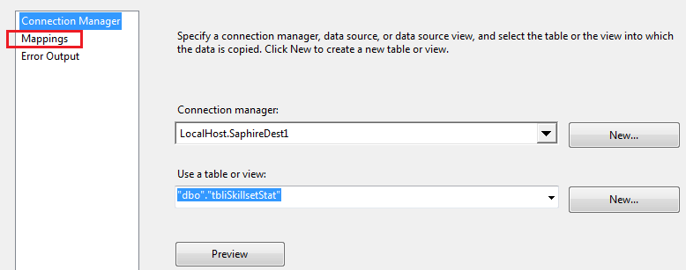

We can use an **ADO .NET** or an **OLE DB destination**

* Assign the table or create a new table click **New** and write the name of the **new table**

CREATE TABLE "**Quarter_I**" (

"ContactType" int,

"QueueType" int,

"QueueNumber" int,

"TimestampUTC" datetime,

"Timestamp" datetime,

"SkillsetID" varchar(100),

"Sk_Ski ……

* Click mapping to check the relationship

